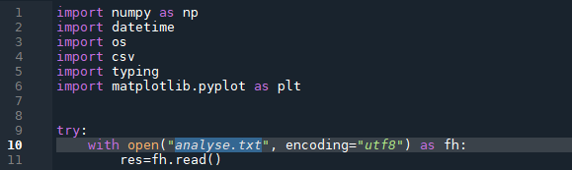
André Dilan

Instructions for use

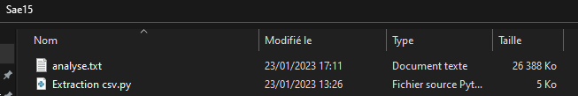
1)First, start by putting the program and the file to be analyzed in the same folder:

2)Then, replace the highlighted area with the name of your file to analyze:

3)After, on line 17 enter the name of your extraction file:

4)On line 22 enter the start time of the extraction (put the current time on the first line if you want to extract from the start):

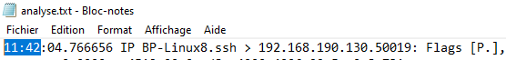

5) On line 114 enter the limit (when the limit is reached the program will stop) :
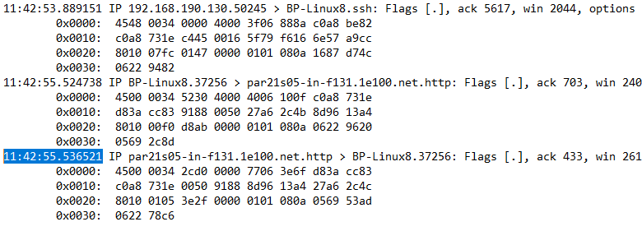
6)Finaly, launch the program. The extraction file will be created in the folder where the program is placed :
